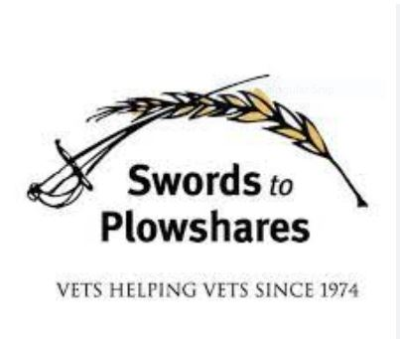

Swords to Plowshares
Call 415-727-VETS (8387) or use the contact us forms via the links below
Housing
Swords to Plowshares helps veterans find a place to live and maintain permanent residence. Swords provide housing for over 500 veterans in our supportive housing programs. Swords work one-on-one with veterans to determine the best options for them to meet their individual needs
Types of housing assistance:
- Emergency & Temporary housing
- Transitional Housing
- Permanent Supportive Housing
- Rent Support
- Eviction Prevention
Supportive Services
Types of services:
- Case Management
- Counseling
- Support Groups
- VA Healthcare Enrollment
Service Centers
Swords to Plowshares Service Centers are the access point for veterans to obtain the resources they need. Upon the first visit, Service Center staff guide veterans to specific services to meet their needs, no matter your discharge status or identity.

